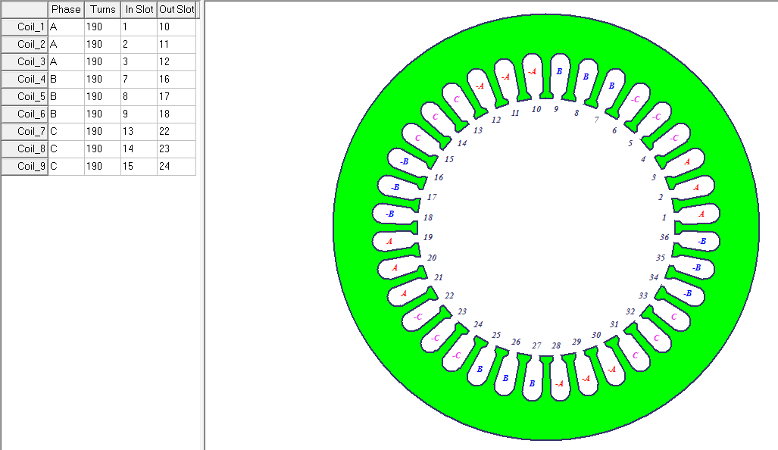

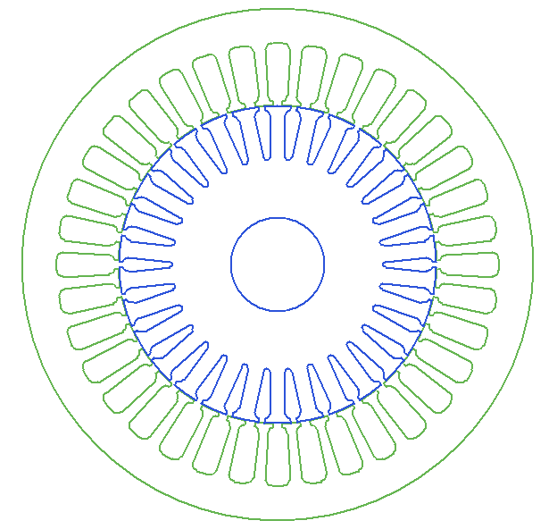

Three-Phase Induction Machine Design

File: Setup1.res

GENERAL DATA

Given Output Power (kW): 1.8

Rated Voltage (V): 380

Winding Connection: Wye

Number of Poles: 4

Given Speed (rpm): 1350

Frequency (Hz): 50

Stray Loss (W): 18

Frictional Loss (W): 11.88

Windage Loss (W): 13.8568

Operation Mode: Motor

Type of Load: Constant Power

Operating Temperature (C): 50

STATOR DATA

Number of Stator Slots: 36

Outer Diameter of Stator (mm): 80

Inner Diameter of Stator (mm): 50

Type of Stator Slot: 4

Stator Slot

hs0 (mm): 0.44

hs1 (mm): 0.86

hs2 (mm): 7.25

bs0 (mm): 1.5

bs1 (mm): 3.24

bs2 (mm): 3.93

rs (mm): 1

Top Tooth Width (mm): 1.35476

Bottom Tooth Width (mm): 1.93114

Length of Stator Core (mm): 49.45

Stacking Factor of Stator Core: 0.95

Type of Steel: D21_50

Number of lamination sectors 3

Press board thickness (mm): 0

Magnetic press board No

Number of Parallel Branches: 1

Type of Coils: 12

Coil Pitch: 9

Number of Conductors per Slot: 190

Number of Wires per Conductor: 1

Wire Diameter (mm): 0.34

Wire Wrap Thickness (mm): 0

Wedge Thickness (mm): 0

Slot Liner Thickness (mm): 0

Layer Insulation (mm): 0

Slot Area (mm^2): 32.621

Net Slot Area (mm^2): 30.1168

Slot Fill Factor (%): 72.9293

Limited Slot Fill Factor (%): 75

Wire Resistivity (ohm.mm^2/m): 0.0217

Conductor Length Adjustment (mm): 0

End Length Correction Factor 1

End Leakage Reactance Correction Factor 1

ROTOR DATA

Number of Rotor Slots: 30

Air Gap (mm): 0.155

Inner Diameter of Rotor (mm): 15

Type of Rotor Slot: 1

Rotor Slot

hs0 (mm): 0.51

hs2 (mm): 6.395

bs0 (mm): 1

bs1 (mm): 2.39

bs2 (mm): 1.04

Cast Rotor: Yes

Half Slot: No

Length of Rotor (mm): 49.45

Stacking Factor of Rotor Core: 0.95

Type of Steel: D21_50

Skew Width: 1

End Length of Bar (mm): 5

Height of End Ring (mm): 5

Width of End Ring (mm): 5

Resistivity of Rotor Bar

at 75 Centigrade (ohm.mm^2/m): 0.0172414

Resistivity of Rotor Ring

at 75 Centigrade (ohm.mm^2/m): 0.0172414

Magnetic Shaft: Yes

MATERIAL CONSUMPTION

Armature Copper Density (kg/m^3): 8900

Rotor Bar Material Density (kg/m^3): 8933

Rotor Ring Material Density (kg/m^3): 8933

Armature Core Steel Density (kg/m^3): 7820

Rotor Core Steel Density (kg/m^3): 7820

Armature Copper Weight (kg): 0.653759

Rotor Bar Material Weight (kg): 0.224188

Rotor Ring Material Weight (kg): 0.0612774

Armature Core Steel Weight (kg): 0.693839

Rotor Core Steel Weight (kg): 0.492401

Total Net Weight (kg): 2.12546

Armature Core Steel Consumption (kg): 1.80945

Rotor Core Steel Consumption (kg): 0.721318

RATED-LOAD OPERATION

Note:

This motor cannot offer the given rated output power.

The following results are at the given rated speed.

Stator Resistance (ohm): 59.2589

Stator Resistance at 20C (ohm): 53.0212

Stator Leakage Reactance (ohm): 26.8224

Rotor Resistance (ohm): 50.4912

Rotor Leakage Reactance (ohm): 32.711

Resistance Corresponding to

Iron-Core Loss (ohm): 11981.5

Magnetizing Reactance (ohm): 640.021

Stator Phase Current (A): 0.499892

Current Corresponding to

Iron-Core Loss (A): 0.0156768

Magnetizing Current (A): 0.293479

Rotor Phase Current (A): 0.371233

Copper Loss of Stator Winding (W): 44.4249

Copper Loss of Rotor Winding (W): 20.8751

Iron-Core Loss (W): 8.83387

Frictional and Windage Loss (W): 25.7368

Stray Loss (W): 18

Total Loss (W): 117.871

Input Power (kW): 0.28001

Output Power (kW): 0.162139

Mechanical Shaft Torque (N.m): 1.1469

Efficiency (%): 57.9048

Power Factor: 0.796339

Rated Slip: 0.1

Rated Shaft Speed (rpm): 1350

NO-LOAD OPERATION

No-Load Stator Resistance (ohm): 59.2589

No-Load Stator Leakage Reactance (ohm): 26.8482

No-Load Rotor Resistance (ohm): 50.4864

No-Load Rotor Leakage Reactance (ohm): 32.8161

No-Load Stator Phase Current (A): 0.32949

No-Load Iron-Core Loss (W): 10.6252

No-Load Input Power (W): 79.6588

No-Load Power Factor: 0.28432

No-Load Slip: 0.0125854

No-Load Shaft Speed (rpm): 1481.12

BREAK-DOWN OPERATION

Break-Down Slip: 0.7

Break-Down Torque (N.m): 3.00365

Break-Down Torque Ratio: 2.61893

Break-Down Phase Current (A): 1.58326

LOCKED-ROTOR OPERATION

Locked-Rotor Torque (N.m): 2.8867

Locked-Rotor Phase Current (A): 1.83612

Locked-Rotor Torque Ratio: 2.51696

Locked-Rotor Current Ratio: 3.67304

Locked-Rotor Stator Resistance (ohm): 59.2589

Locked-Rotor Stator

Leakage Reactance (ohm): 25.5468

Locked-Rotor Rotor Resistance (ohm): 50.9699

Locked-Rotor Rotor

Leakage Reactance (ohm): 28.1351

DETAILED DATA AT RATED OPERATION

Stator Slot Leakage Reactance (ohm): 11.7801

Stator End-Winding Leakage

Reactance (ohm): 11.0303

Stator Differential Leakage

Reactance (ohm): 4.01204

Rotor Slot Leakage Reactance (ohm): 15.1642

Rotor End-Winding Leakage

Reactance (ohm): 2.5312

Rotor Differential Leakage

Reactance (ohm): 10.3278

Skewing Leakage Reactance (ohm): 4.68785

Stator Winding Factor: 0.959795

Stator-Teeth Flux Density (Tesla): 1.62957

Rotor-Teeth Flux Density (Tesla): 1.2793

Stator-Yoke Flux Density (Tesla): 1.47274

Rotor-Yoke Flux Density (Tesla): 0.515952

Air-Gap Flux Density (Tesla): 0.576885

Stator-Teeth Ampere Turns (A.T): 48.2618

Rotor-Teeth Ampere Turns (A.T): 8.5858

Stator-Yoke Ampere Turns (A.T): 29.9391

Rotor-Yoke Ampere Turns (A.T): 0.80493

Air-Gap Ampere Turns (A.T): 115.615

Correction Factor for Magnetic

Circuit Length of Stator Yoke: 0.419158

Correction Factor for Magnetic

Circuit Length of Rotor Yoke: 0.7

Saturation Factor for Teeth: 1.4917

Saturation Factor for Teeth & Yoke: 1.75762

Induced-Voltage Factor: 0.856147

Stator Current Density (A/mm^2): 5.5059

Specific Electric Loading (A/mm): 21.7677

Stator Thermal Load (A^2/mm^3): 119.851

Rotor Bar Current Density (A/mm^2): 5.99882

Rotor Ring Current Density (A/mm^2): 7.81467

Half-Turn Length of

Stator Winding (mm): 118.283

WINDING ARRANGEMENT

The 3-phase, 1-layer winding can be arranged in 18 slots as below:

AAAZZZBBBXXXCCCYYY

Angle per slot (elec. degrees): 20

Phase-A axis (elec. degrees): 110

First slot center (elec. degrees): 0

TRANSIENT FEA INPUT DATA

For one phase of the Stator Winding:

Number of Turns: 1140

Parallel Branches: 1

Terminal Resistance (ohm): 59.2589

End Leakage Inductance (H): 0.0351105

For Rotor End Ring Between Two Bars of One Side:

Equivalent Ring Resistance (ohm): 3.92266e-006

Equivalent Ring Inductance (H): 4.10664e-009

2D Equivalent Value:

Equivalent Model Depth (mm): 49.45

Equivalent Stator Stacking Factor: 0.95

Equivalent Rotor Stacking Factor: 0.95

Estimated Rotor Inertial Moment (kg m^2): 0.000230854